|  |  |  |
| --- | --- | --- |
| C:\Users\A04659\Desktop\数据中心\公司系统相关资料\关于明阳商标使用的温馨提示\01.png | **风力发电机组**Wind turbine | **日期Date** |
| **2019-09-09** |
| **明阳监控系统使用手册**  **MingYang Monitoring System User Manual**   |  |  |  |  |  | | --- | --- | --- | --- | --- | | **编制Prepared by**  **王海存** | **校对Checked by**  **邓冬冬** | **标准化Standardized by**  **田宛灵** | **批准Approved by**  **高宇洋** | **发布Released by**  **银磊** | |  |  |  |  |  |  |  |  |  |  | | --- | --- | --- | --- | | **文件号Document No.** |  | **版本Revision** | **A** | | **密级Classification** | | **页码Number of pages** | **35** | | **□绝密Strictly Confidential ■机密Confidential □秘密 Secret □内部 Internal□公开Published** | | | | | | |

|  |
| --- |
| **注意事项和声明**  **Notification and Disclaimer**  本文件中所有的事项尽可能的全面和准确，但本文件可能还需要进一步修正。未经明阳智慧能源集团股份公司确认和许可而依据此文件进行制造和其他用途时，明阳智慧能源集团股份公司将不负责因此所产生的风险。  任何发现有关本文件的不足和错误之处，请文件使用者立即反馈给版权所有者。  本文件仅在接收方同意以上条件时才给予提交。当文本有歧义时，请以中文为准。  This document may still be undergoing checking by the institution responsible, Although all work has been carried out very thoroughly; this document is still subject to changes. Without permission from MINGYANG, the risk of manufacturing that in accordance to this document or other uses is not in the responsibility of MINGYANG.  Should any information in this document be not complete, incomprehensible or faulty, it is the responsibility of the user of this document to immediately clarify the facts with the author and the client.  This document is only submitted under the assumption that the receiver accepts the above conditions. In case of any divergence of interpretations, the Chinese version shall prevail. |
|  |

**有效附件**

**List of Valid Documents**

|  |  |  |  |
| --- | --- | --- | --- |
| **序号**  **Item No.** | **文件名**  **Document Name** | **文件号**  **Document No.** | **版本**  **Rev.** |
|  |  |  |  |
|  |  |  |  |
|  |  |  |  |
|  |  |  |  |
|  |  |  |  |

**更改记录表**

**List of Alterations**

|  |  |  |  |  |
| --- | --- | --- | --- | --- |
| **序号**  **Item No.** | **版本**  **Rev.** | **所在页**  **Modified Pages** | **更改内容**  **Modifications** | **日期**  **Date** |
|  |  |  |  |  |
|  |  |  |  |  |
|  |  |  |  |  |
|  |  |  |  |  |
|  |  |  |  |  |
|  |  |  |  |  |
|  |  |  |  |  |
|  |  |  |  |  |
|  |  |  |  |  |
|  |  |  |  |  |
|  |  |  |  |  |
|  |  |  |  |  |
|  |  |  |  |  |
|  |  |  |  |  |
|  |  |  |  |  |
|  |  |  |  |  |
|  |  |  |  |  |
|  |  |  |  |  |
|  |  |  |  |  |
|  |  |  |  |  |

**目录**

**Content**

1．监控系统概述 Overview of Monitoring System 5

2．监控系统主要功能 Main Functions of Monitoring System 6

2.1数据采集功能 Data Acquisition Function 6

2.2数据处理功能 Data Processing Function 6

2.3安全监视功能 Security Monitoring Function 7

2.4画面显示 Screen Display 7

2.5日志及报表 Logs and Reports 7

2.6控制功能 Control Function 7

3．监控系统结构介绍 Introduction to the Structure of Monitoring System 7

3.1监控系统主要设备系统图 System Diagram of Main Equipment of Monitoring System 7

3.2网络结构 Network structure 8

3.3监控系统硬件结构 Hardware Structure of Monitoring System 9

4．监控系统设备维护及注意事项Monitoring System Equipment Maintenance and Matters Needing Attention 10

4.1网络维护 Network Maintenance 10

4.2服务器维护 Server Maintenance 11

4.3操作站维护 Operation Station Maintenance 11

5．监控系统软件使用说明 Instructions for the Use of Monitoring System Software 11

5.1风场实时监视 Real-time Monitoring of Wind Field 11

5.2实时数据查询 Real-time Data Query 18

5.3数据查询Data Query 18

5.4报表统计功能 Report Statistics Function 21

5.5曲线分析 Curve Analysis 25

5.6箱变 Box Transformer 33

5.7风机控制 Wind Turbine Generator System(Wtgs) Control 34

5.8设置 Set up 36

# 监控系统概述 Overview of Monitoring System

明阳风电场监控系统主要对分布在不同位置的风力发电机组运行情况及生产运行数据进行实时采集、监控和控制，使监控中心能够及时准确地了解风机的生产运行状况。

本手册作为明阳风电场监控系统的用户操作说明书，适用于风电场V1.5以上版本中央监控系统，以下内容主要介绍了整个系统的网络结构和各画面的详细功能及特点，并配以相应的图片指示说明各操作步骤。

The monitoring system of Mingyang Wind Farm mainly collects, monitors and controls the operation status and production operation data of Wtgs distributed in different locations in real time, so that the monitoring center can timely and accurately understand the production operation status of the Wtgs.

This manual serves as the user operation manual for the monitoring system of Mingyang Wind Farm, which is applicable to the central monitoring system of wind farm V1.5 and above. The following content mainly introduces the network structure of the entire system and the detailed functions and characteristics of each screen, with corresponding the picture instructions illustrate the steps.

# 2．监控系统主要功能 Main Functions of Monitoring System

监控系统为风电场运行与管理提供完整的自动化监控，为上级系统提供数据与信息服务，具体功能如下：

The monitoring system provides complete automated monitoring for the operation and management of the wind farm, and provides data and information services for the upper-level system. The specific functions are as follows

## 2.1数据采集功能 Data Acquisition Function

• 接收各风机主控系统上送的风机运行状态、运行数据、报警代码、实时电能量数据等信息。

Receive information such as Wtgs operating status, operating data, alarm code, real-time electrical energy data and other information sent from the main control system of each Wtgs.

## 2.2数据处理功能 Data Processing Function

• 对接收的数据生成实时数据库；

Generate real-time database of received data;

• 生成历史数据记录；

Generate historical data records;

• 生成各类运行报表；

Generate various operating reports;

• 生成各类曲线图表；

Generate all kinds of curve charts;

• 具有数据统计能力，汇总风机运行时间、有功、无功、可用功率、电量累计、统计与分析；

With data statistics ability, summarizing Wtgs running time, active power, reactive power, available power, power accumulation, statistics and analysis

• 设备故障报警统计与分析等。

Equipment failure alarm statistics and analysis, etc.

## 2.3安全监视功能 Security Monitoring Function

• 设备的运行状态和参数进行监视管理。

Monitoring and management of equipment operating status and parameters.

## 2.4画面显示 Screen Display

• 监控系统客户机能显示风机各种信息画面，主要包括全部风机的运行状态、发电量、设备的温度等各测量值的实时数据、各种报警信息、报警及记录等。

The monitoring system client can display various information screens of the Wtgs, mainly including real-time data of all measured values such as the running status of all fans, power generation, and equipment temperature, various alarm information, alarms and records, etc.

## 2.5日志及报表 Logs and Reports

• 监控系统能生成和打印运行日志和报表，包括风机参数报表，发电量统计报表，综合统计表等。

The monitoring system can generate and print operation logs and reports, including Wtgs parameter reports, power generation statistics reports, comprehensive statistics tables, etc.

## 2.6控制功能 Control Function

• 通过监控系统能远程对风机进行控制和操作。

Through the monitoring system, the Wtgs can be controlled and operated remotely.

# 3．监控系统结构介绍 Introduction to the Structure of Monitoring System

## 3.1监控系统主要设备系统图 System Diagram of Main Equipment of Monitoring System

如下图3.1：

Figure 3.1 below:

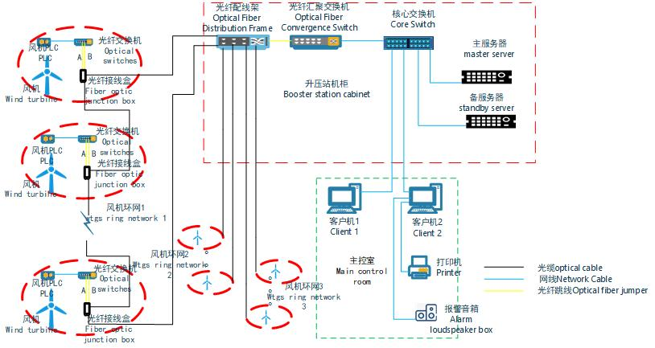

图3.1 系统结构图

Figure 3.1 System Structure Diagram

## 3.2网络结构 Network Structure

中央监控系统采用闭环的网络结构。一般每个风场根据环境位置及风机数量会配置多个闭环网络。每台风电机组配置一台工业级交换机。

The central monitoring system adopts a closed-loop network structure. Generally, each wind field will be equipped with multiple closed-loop networks according to the environmental location and the number of Wtgs. Each Wtgs is equipped with an industrial-grade switch.

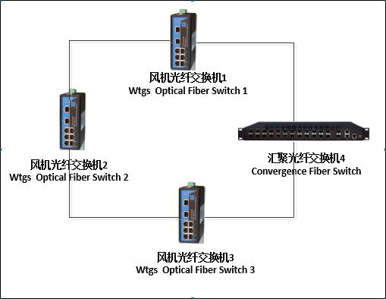

图3.2 环网图

Figure 3.2 Loop Network Diagram

上图中，如果交换机1和交换机4之间的所有网络断开，则所有原来通过交换机1和交换机4之间的通讯能够通过交换机1交换机2交换机3交换机4来获得，所有的切换过程不要人工干预，而且不会丢失任何通讯数据。所以，闭环网络中任何一点断开都对网络通讯没有任何影响。

In the figure above, if all the networks between switch 1 and switch 4 are disconnected, all the communication between switch 1 and switch 4 can be obtained through switch 1, switch 2, switch 3 and switch 4. All the switching processes need not be interfered with manually, and no communication data will be lost. Therefore, any disconnection in the closed-loop network has no effect on network communication.

## 3.3监控系统硬件结构 Hardware Structure of Monitoring System

## 3.3.1监控系统主要硬件设备 Main Hardware Equipment of Monitoring System

服务器，工业级交换机，服务器机柜，UPS电源，操作员站计算机等。

Server, industrial grade switch, server cabinet, UPS power supply, operator station computer, etc.

### 3.3.2中央监控室系统部分Central Monitoring Room System

中央控制室标准配置2台服务器和2台操作站计算机。服务器配置为一主一备双服务器。操作站数量可以按照用户的要求配置为更多数量，每个操作员站的功能完全相同，而不会互相冲突。中央控制室其中一个操作站标配一个报警音箱。

The central control room is equipped with 2 servers and 2 operation station computers as standard. The server is configured as one main and one standby dual server. The number of operator stations can be configured to a larger number according to user requirements, and the functions of each operator station are exactly the same without conflict with each other. One of the operation stations in the central control room is equipped with an alarm speaker as standard.

### 3.3.3塔基柜监控系统部分 Tower Base Cabinet Monitoring System

塔基柜监控系统部分主要为一台监控系统工业交换机。交换机配置两个光口多个电口，交换机电源采用塔基柜控制系统的电源。所有的塔基柜工业交换机通过光口连接为一个闭环网络。

The tower base cabinet monitoring system is mainly a monitoring system industrial switch. The switch is equipped with two optical ports and multiple electrical ports, and the switch power supply adopts the power supply of the tower base cabinet control system. All tower base cabinet industrial switches are connected to a closed loop network through optical ports.

监控系统配置主要设备如下表4.1

The main equipment of the monitoring system configuration is as follows Table 4.1.

|  |  |  |  |
| --- | --- | --- | --- |
| 名称  Name | 数量Quantity | 单位Unit | 说明  Explaination |
| 数据服务器  Data Server | 2 | 套  Set | 实时数据采集，数据处理，实时数据库更新及管理，数据查询等  Real-time data acquisition, data processing, real-time database update and management, data query, etc. |
| 操作员工作站  Operator workstation | 2 | 套  Set | 用于运行监控系统软件。运行值班人员通过操作员站实现对风机的监视、控制及管理  Used for running the monitoring system software. The operation staff on duty monitors, controls and manages the fan through the operator station. |
| 语音报警音箱  Voice alarm speaker | 1 | 台  Set | 用于风机发生故障或异常时的语音报警  Used for voice alarm in case of Wtgs fails or abnormal. |
| 报表打印机  Report Printer | 1 | 台  Set | 报表及相关文档的打印  Printing of reports and related documents. |
| 核心交换机  Core Switch | 1 | 套  Set | 构成监控系统的主干网络  The backbone network of the monitoring system. |
| 光纤汇聚交换机  Optical Fiber Convergence Switch | 1 | 套  Set | 用于光纤环网信号的接入  For the access of optical fiber ring network signal. |
| UPS电源  UPS power supply | 1 | 套  Set | 用于系统及网络设备的供电保障  Power supply guarantee for system and network equipment. |

表4.1 系统设备配置表

Table 4.1 System Equipment Configuration Table

# 4．监控系统设备维护及注意事项Monitoring System Equipment Maintenance and Matters Needing Attention

# 4.1网络维护 Network Maintenance

确保网络通信传输畅通，定期检查交换机等设备运行状态。

Ensure smooth network communication and regularly check the operating status of switches and other equipment.

确保网络应用服务不间断运行。

Ensure the uninterrupted operation of network application services.

网络设备连接线做好标识记录。

Make a record of the identification of the network equipment connection line.

### 4.2服务器维护 Server Maintenance

为了能更好的使用和延长服务器的使用寿命，定期的对服务器进行维护是非常必要的。但是，在维护服务器的时候一定要小心的处理好维护的工作，否则出现错误的话就会影响很大。下面一些信息供参考：

In order to better use and extend the service life of the server, it is necessary to maintain the server regularly. However, when maintaining the server, you must carefully handle the maintenance work, otherwise an error will have a great impact. The following information is for reference:

### 4.2.1设备的卸载和更换 Uninstallation and Replacement of Equipment

必须在完全断电、服务器接地良好的情况下进行设备的卸载和更换，即使是支持热插拔的设备也是如此，以防止静电对设备造成损坏。

The device must be unloaded and replaced when the power is completely cut off and the server is well grounded, even if it is a device that supports hot swap, to prevent static electricity from damaging the device.

### 4.2.2除尘 Remove Dust

尘土是服务器最大的杀手，因此需要定期给服务器除尘。对于服务器来说，灰尘甚至是致命的。除尘方法与普通 PC 除尘方法相同，尤其要注意的是电源的除尘。

Dust is the biggest killer of the server, so it is necessary to dust the server regularly. For servers, dust is even fatal. The dust removal method is the same as the ordinary PC dust removal method, especially the dust removal of the power supply.

### 4.3操作站维护 Operation Station Maintenance

操作站必须做好防病毒管理，禁止在操作员站上使用 U 盘等可能感染病毒的设备。操作站上备份当前系统，如果操作站不能正常启动运行，请在启动时采用还原的方法恢复系统。

不要安装任何第三方软件，更不要注册未知的组件。

The operator station must do a good job of anti-virus management, and it is prohibited to use U disk and other devices that may be infected with viruses on the operator station. Back up the current system on the operating station. If the operating station cannot start up and run normally, please restore the system when starting up.

Do not install any third-party software, let alone register unknown components.

# 5．监控系统软件使用说明 Instructions for the Use of Monitoring System Software

### 5.1风场实时监视 Real-time Monitoring of Wind Field

### 5.1.1全场风机总览 Overview of Wtgs

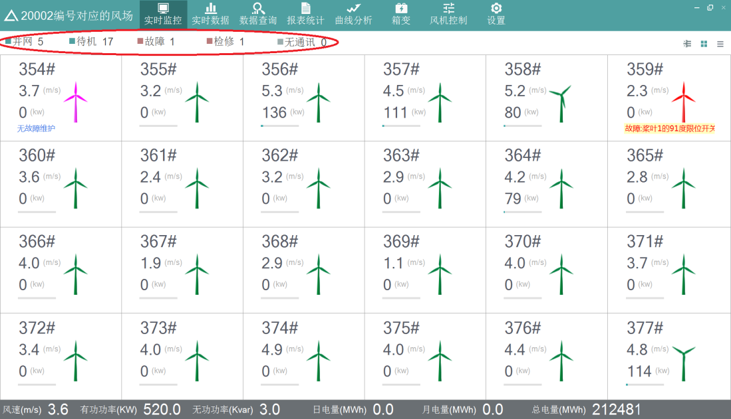实时监视界面主要显示风场和风机的各种实时运行数据。登录成功后，默认显示风场实时监视界面，用来显示该风场下全部风机的运行状态、风速和功率，状态包括并网、待机、故障、检修、无通信五种。不同的状态用不同的颜色区分，主界面显示如图 5.1 所示。

The real-time monitoring interface mainly displays various real-time operating data of wind fields and Wtgs. After a successful login, the real-time monitoring interface of the wind farm is displayed by default, which is used to display the running status, wind speed and power of all Wtgs in the wind field. The status includes five types: grid connection, standby, fault, maintenance, and no communication. Different states are distinguished by different colors. The main interface display is shown in Figure 5.1.



图 5.1 主界面显示图

Figure 5.1 Main Interface Display Diagram

点击 第一个按钮，可以切换选择线路查看该线路下的风机的运行状态，如下选择线路 1，此时显示的风机为线路 1 下的风机，如图 5.2 所示。

Click on the first button, you can switch the selected line to view the operating status of the Wtgs under this line, select line 1 as follows, and the Wtgs displayed at this time are the Wtgs under line 1, as shown in Figure 5.2 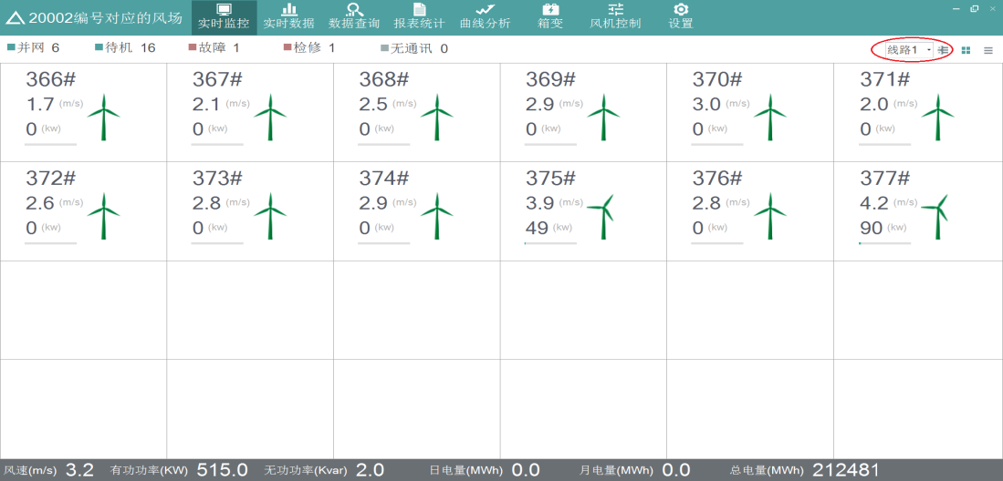

图 5.2 分组显示风机界面图

Figure. 5.2 Grouped Display of Wtgs Interface

点击 第二个按钮，即可切换回全场风机的显示，如图 5.1 所示。

Click on the second button to switch back to the display of the whole Wtgs, as shown in Fig. 5.1.

点击 第三个按钮，全场风机的信息及状态以表格的形式显示，如图5.3所示。

Click on the third button, the information and status of the whole Wtgs are displayed in tabular form, as shown in Fig. 5.3.

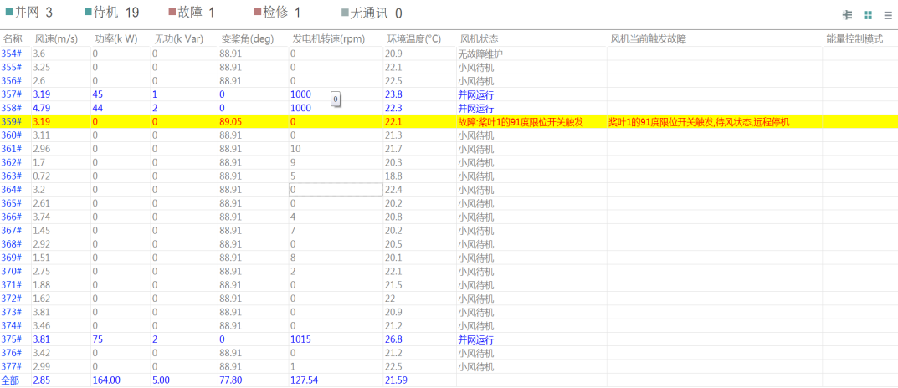

图 5.3 表格显示图

Figure 5.3 Table Display

主界面上方工具条为导航栏，点击导航栏上的按钮可方便切换到各个应用页面，如图5.4 所示。

The toolbar at the top of the main interface is the navigation bar. Click the button on the navigation bar to easily switch to each application page, as shown in Figure 5.4.



图 5.4 应用页面图

Figure 5.4 Application Page Diagram

### 5.1.2全场信息量刷新 Full field information refresh

主界面下方的工具栏实时显示全场的风速、有功功率、无功功率、日电量、月电量和总电量，如图 5.5 所示。

The toolbar at the bottom of the main interface displays real-time wind speed, active power, reactive power, daily power, monthly power, and total power of the audience, as shown in Figure 5.5.



图 5.5 工具栏图

Figure 5.5 Toolbar Diagram

### 5.1.3风机实时监视 Real-time Monitoring of Wtgs

在主界面上点击某台风机，进入风机实时监控界面，显示该台风机的详细信息，包括实时功率、风速、变浆角、转速等全部实时数据和全部信号量数据，风机以及业主基本信息，当前最近的故障、状态等历史记录。主要包括如下几个功能界面，如图 5.6 所示。

Click on a Wtgs on the main interface to enter the real-time monitoring interface of the Wtgs, and display the detailed information of the Wtgs, including all real-time data such as real-time power, wind speed, variable pitch angle, rotation speed and all signal data, basic information of the Wtgs and the owner. The current and recent faults, status and other historical records. It mainly includes the following functional interfaces, as shown in Figure 5.6.

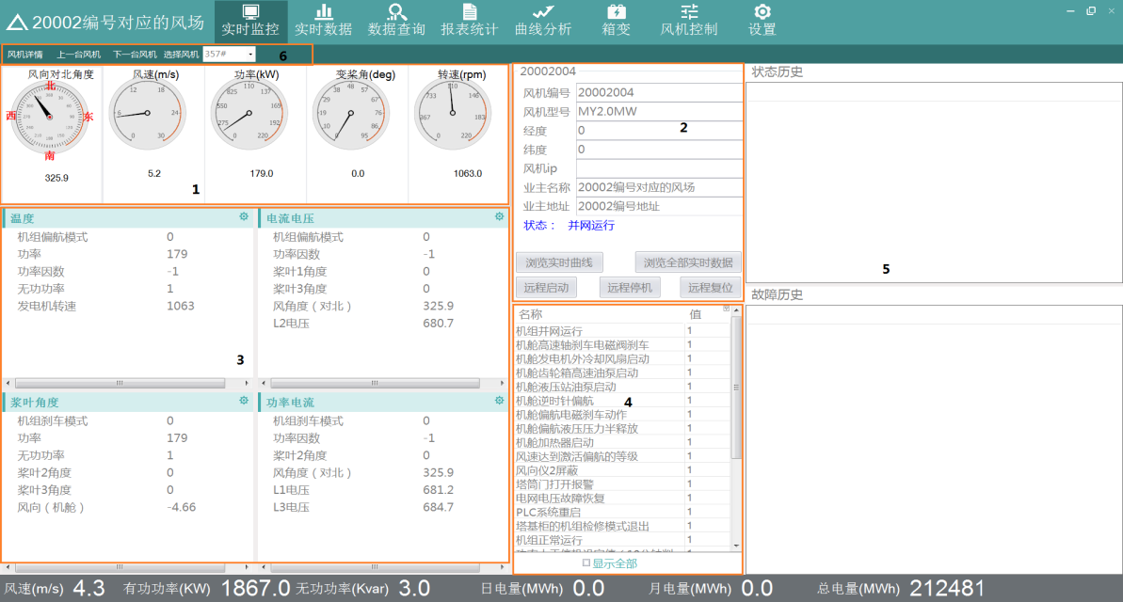

图 5.6 风机实时监控界面图

Figure 5.6 Interface Diagram of Wtgs Real-time Monitoring

风机总览页面可分为图中所示的 6 个区域。具体的说明如表 5.1 所示。

The Wtgs overview page can be divided into six areas shown in the figure. Specific instructions are shown in Table 5.1.

|  |  |
| --- | --- |
| 序号  Serial number | 说明  Explanation |
| 1 | 以仪表盘直观地显示风机的风向对北角度、风速、功率、变浆角、转速信息。  Intuitively display the wind direction of the Wtgs to the north angle, wind speed, power, variable pitch angle, and speed information with the dashboard. |
| 2  3 | 显示风机的静态信息、状态以及部分统计信息、业主的名称和地址。  Display the static information, status and some statistical information of the Wtgs, the name and address of the owner.  对风机进行启动、停机、复位等操作，可浏览实时曲线及实时数据。  Start, stop, and reset the Wtgs, and browse real-time curves and real-time data. |
| 4 | 可配置显示风机的 IO 信息。  Configurable to display the IO information of Wtgs. |
| 5 | 显示风机的 SC 信息。  Display SC Information of Wtgs. |
| 6 | 显示最近一个月的历史状态和故障历史。  Display the historical status and fault history of the last month. |
| 7 | 工具栏点击上一台风机或下一台风机，选择某台风机，可快速切换显示所选风机，不用切换回主界面。  Click on the previous Wtgs or the next Wtgs on the toolbar to select a Wtgs to quickly switch and display the selected Wtgs without switching back to the main interface. |

表5.1 风机页面说明表

Table 5.1 Wtgs Page Description Table

### 5.1.4浏览实时曲线 Browse Real-time Curves

点击“浏览实时曲线”按钮，可查看当前风机的实时数据，选择时间间隔（20 分钟、1小时、1 天），开始时间后，点击“查询”，相应的查询曲线显示如图 5.7 所示。

Click the "Browse Real-time Curve" button to view the real-time data of the current Wtgs. Select the time interval (20 minutes, 1 hour, 1 day). After the start time, click "Query" and the corresponding query curve will be displayed as shown in Figure 5.7.

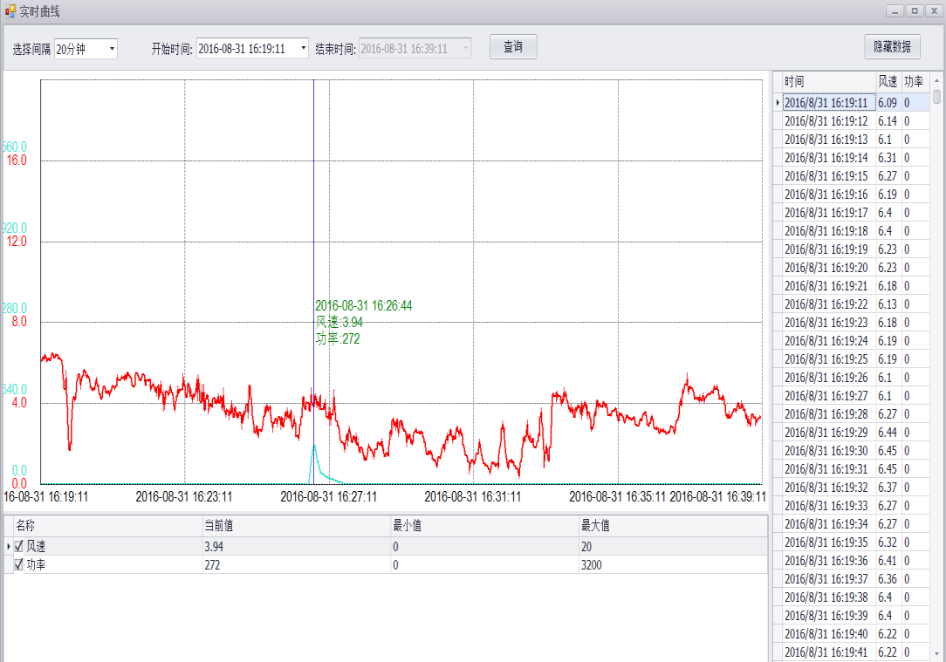

图 5.7 查询曲线图

Figure 5.7 Query Chart

当选择间隔为 20 分钟时，查询的数据间隔为 1 秒；当选择间隔为 1 小时，查询的数据间隔为 3 秒；当选择间隔为 1 天时，查询的数据间隔为 1 分钟。

点击下面的 IO，改变其 check 状态，相应的曲线及右边列表的显示会跟着改变。点击曲线，会显示该点的时间及相应的 IO 值。

点击“隐藏数据”，右边表格会隐藏，相应的按钮变成“显示数据”。点击“显示数据”，右边表格会显示，按钮变成“隐藏数据”。

When the selection interval is 20 minutes, the query data interval is 1 second; when the selection interval is 1 hour, the query data interval is 3 seconds; when the selection interval is 1 day, the query data interval is 1 minute.

Click on the IO below to change its check status, and the display of the corresponding curve and the list on the right will follow. Click on the curve to show the time of the point and the corresponding IO value.

Click "Hide Data", the table on the right will be hidden, and the corresponding button will become "Show Data". Click on "Show Data" and the table on the right will display. The button will become "Hide Data".

### 5.1.5浏览全部实时数据Browse all real-time data

点击“浏览全部实时数据”，可以查看该风机的全部 IO 实时信息。如图 5.8 所示。

Click "Browse all real-time data" to view all IO real-time information of the wtgs. As shown in Figure 5.8.

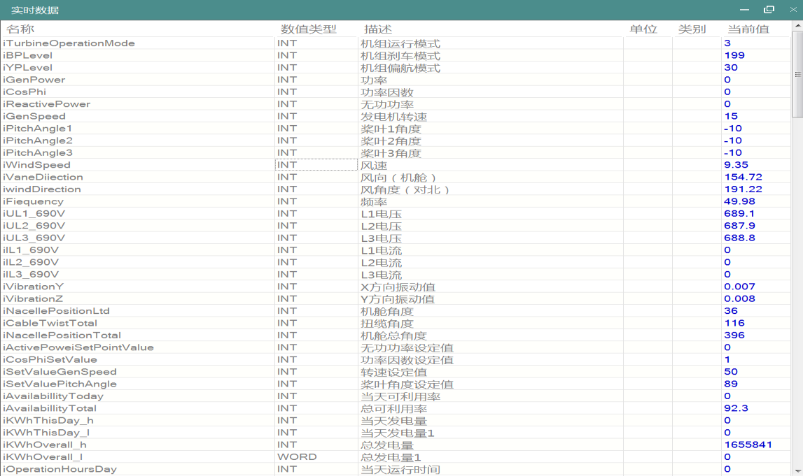

图 5.8 实时数据图

Figure 5.8 Real-time data graph

### 5.1.6远程启停机、复位 Remote Start-Down and Reset

点击“远程启动”、“远程停机”、“远程复位”按钮，可对改风机进行启动、停机、复位操作。

Click on the buttons of "remote start", "remote shutdown" and "remote reset" to start, stop and reset the wtgs.

### 5.1.7配置 IO 信息 Configure IO information

在区域 3 中点击 ，在模拟量选择界面中，可配置选择需要显示的风机 IO 信息，如图5.9 所示。

Click in Area 3, and in the Analog Selection Interface, you can configure the wtgs IO information to be displayed, as shown in Figure 5.9.

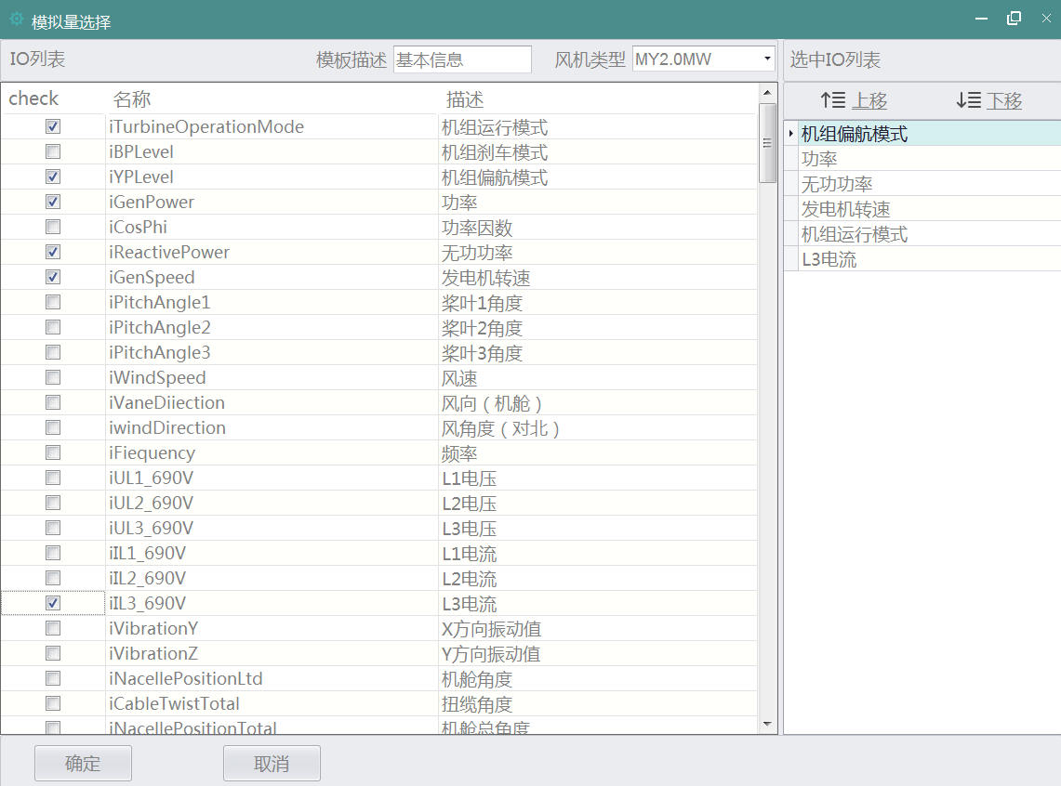

图 5.9 模拟量选择图

Figure 5.9 Analog Selection Diagram

在图 5.9 中，左边为某个风机类型的全部 IO 列表，右边为选中的 IO 列表，点击左边 IO列表中的 IO，check 即为选中状态，此 IO 即加到选中 IO 列表。在右边选中 IO 列表中，通过拖拽节点和“上移”“下移”按钮，可调整 IO 列表顺序。操作完毕，点击“确定”按钮，所选的 IO，即加到实时数据列表中。点击“取消”按钮，即关闭窗口。

In Figure 5.9, the left side is a list of all IOs for a wtgs type, and the right side is a list of selected IOs. Click IO in the left IO list, check is the selected state, and this IO is added to the selected IO list. In the IO list selected on the right, the order of IO list can be adjusted by dragging and dropping the node and the "Up" and "Down" buttons. After the operation, click on the "OK" button and add the selected IO to the real-time data list. Click the Cancel button to close the window.

### 5.2实时数据查询 Real-time Data Query

点击主界面上面工具栏的“实时数据”按钮，可查看所有风机的实时数据，红色的表示有故障，蓝色的表示并网，灰色的表示无通信，如图 5.10 所示。

Click on the "Real-time Data" button of the toolbar above the main interface to view the real-time data of all wtgss. The red one shows fault, the blue one shows grid connection, and the gray one shows no communication, as shown in Fig. 5.10.

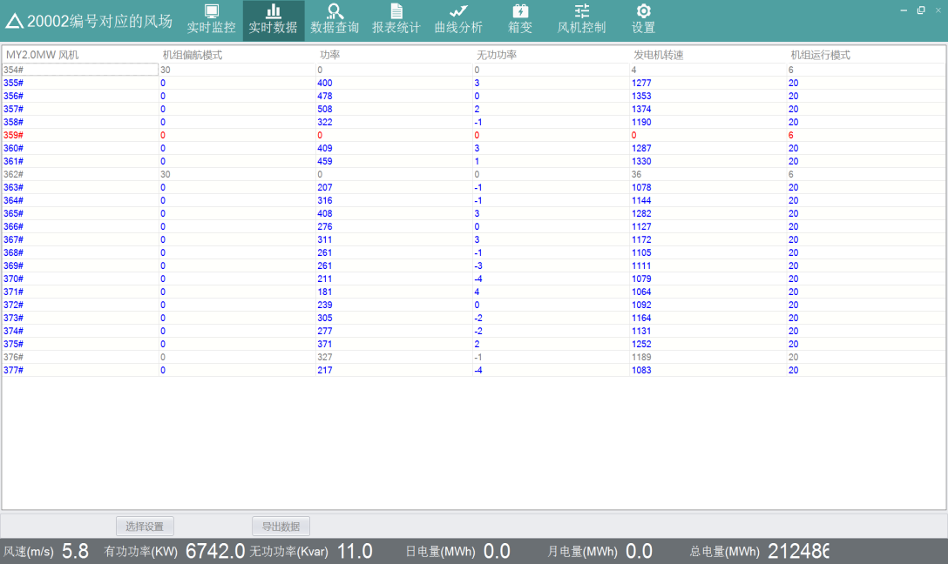

图 5.10 实时数据图

Figure 5.10 Real-time data graph

点击“选择设置”按钮，在模拟量选择界面中，可配置选择需要显示的风机 IO 信息。点击“导出数据”，可将实时数据以 csv 格式导出到本地。

Click on the "Select Settings" button to configure the wtgs IO information to be displayed in the analog selection interface. Click "Export Data" to export real-time data to the local area in CSV format.

### 5.3数据查询Data Query

点击主界面上面工具栏的“数据查询”按钮，可查看风机的故障数据、状态数据、分钟数据、Tracelog 数据、StatusCode 数据。

Click on the "Data Query" button in the toolbar above the main interface to view the wtgs fault data, status data, minute data, Tracelog data, StatusCode data

### 5.3.1故障数据查询Fault Data Query

点击“数据查询”->“故障数据”，首先在左边风机列表中，选择要查询的风机，再在上边选择查询的开始时间和结束时间。查询条件选择完成后，点击“查询”，表格中显示查询的结果，主要包括故障名称、故障的开始与结束时间、持续时长等。点击“导出”，可将查询结果以 csv 格式导出到本地。如图 5.11 所示。

Click on "Data Query" - > "Fault Data", first in the left wtgs list, select the wtgs to query, and then on the top select the start and end time of the query. After the selection of the query conditions is completed, click "Query" and the results of the query are displayed in the table, including the name of the fault, the start and end time of the fault, and the duration of the fault. Click "Export" to export the query results to the local area in CSV format. As shown in Figure 5.11.

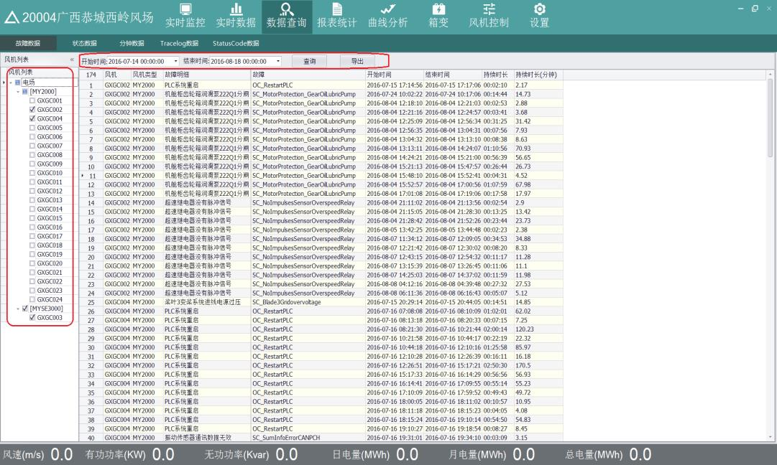

图 5.11 数据导出图

Figure 5.11 Data Export Diagram

### 5.3.2状态数据查询 State Data Query

点击“数据查询”->“状态数据”，首先在左边风机列表中，选择要查询的风机，再在上边选择查询的开始时间和结束时间。查询条件选择完成后，点击“查询”，表格中显示查询的结果，主要包括风机的类型、状态码与状态描述、首触码与首触码描述等。点击“导出”，可将查询结果以 csv 格式导出到本地。如图 5.12 所示。

Click on "Data Query" - > "State Data". First, in the list of wtgss on the left, select the wtgs to query, and then select the start and end time of the query on the top. After the selection of query conditions is completed, click "Query" and the results of query are displayed in the table, including wtgs type, status code and status description, first touch code and first touch code description, etc. Click "Export" to export the query results to the local area in CSV format. As shown in Figure 5.12.

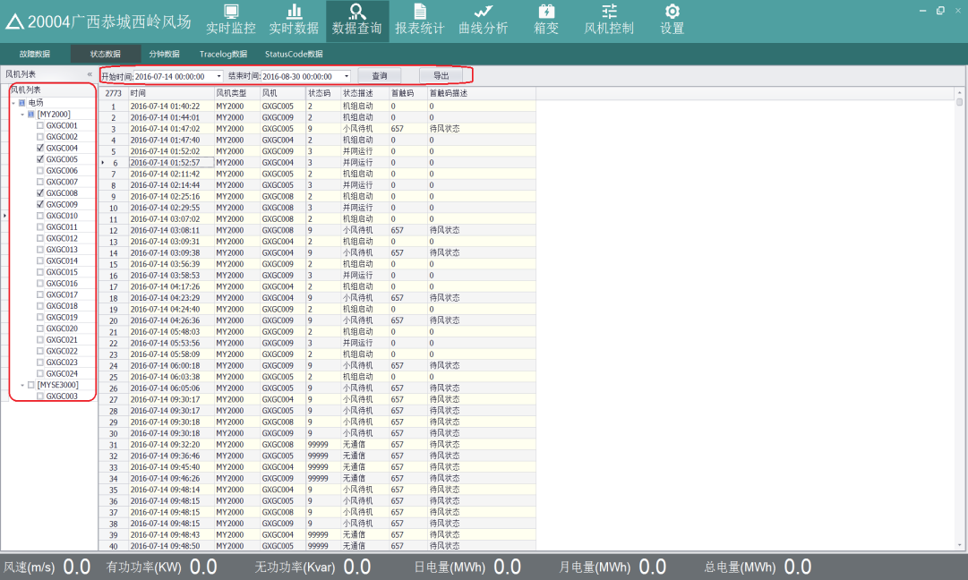

图 5.12 状态数据图

Figure 5.12 Status Data Diagram

### 5.3.3分钟数据查询 Minute Data Query

点击“数据查询”->“分钟数据”，首先在左边风机列表中，选择要查询的风机，再在中间对应的 IO 列表中，选择查询的 IO 量，最后在上边选择需要查询的数据类型（默认为十分钟数据）、查询的开始时间和结束时间。查询条件选择完成后，点击“查询”，表格中显示查询的结果，主要包括时间、选择的风机编号、选择的 IO 信息。点击“导出”，可将查询结果以 csv 格式导出到本地。如图 5.13 所示。

Click on "Data Query" - > "Minute Data". First, in the left wtgs list, select the wtgs to query, then in the corresponding IO list in the middle, select the IO quantity of the query, and finally select the data type (default is 10 minutes data), the start time and end time of the query. After the selection of query conditions is completed, click "Query" and the results of query are displayed in the table, which mainly includes the time, the number of wtgs selected and the IO information selected. Click "Export" to export the query results to the local area in CSV format. As shown in Figure 5.13.

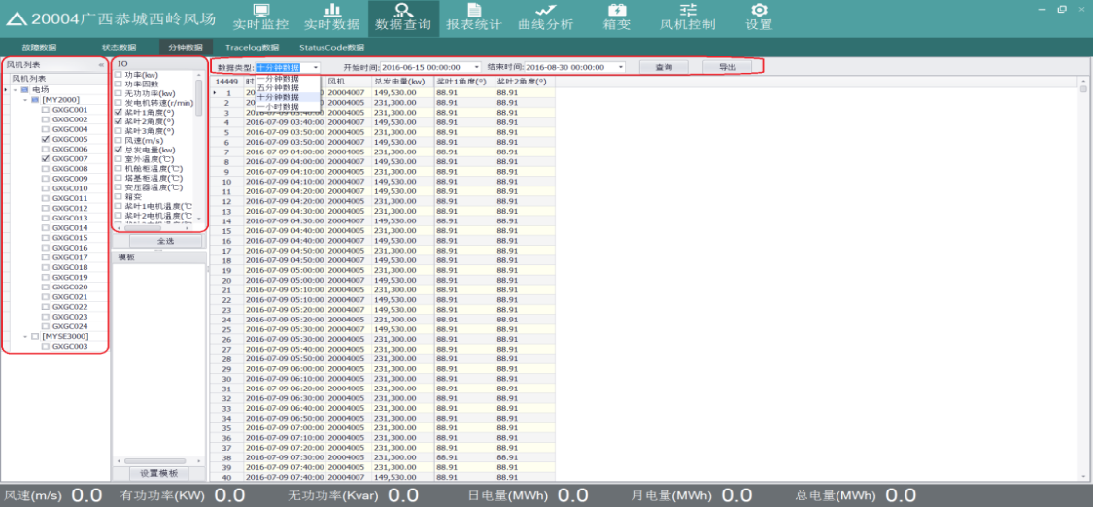

图 5.13 分钟数据图

Figure 5.13 Minute Data Diagram

注：只能选择同种类型下的风机进行查询，因为不同类型的风机对应的 IO 不同。在图中，点击“全选”按钮，即选中全部 IO。

Note: Only the same type of wtgs can be selected for query, because different types of wtgs have different IO. In the figure, click the "Select All" button to select all IO.

### 5.4报表统计功能 Report Statistics Function

点击主界面上面工具栏的“报表统计”按钮，可查看风机的发电量统计、风机性能统计、损失发电量。

Click on the "Report Statistics" button in the toolbar above the main interface to view the statistics of wtgs power generation, wtgs performance and loss of power generation.

### 5.4.1发电量统计 Generation statistics

点击“报表统计”->“发电量统计”，首先在左边风机列表中，选择要查询的风机，再在上边选择查询的时间间隔类型（时、日、月）、查询的开始时间和结束时间。查询条件选择完成后，点击“查询”，表格中显示查询的结果，主要包括风机、风机类型、时间、平均风速、最大风速、最小风速、发电量。点击“导出”，可将查询结果以 csv 格式导出到本地。

选择“时报”，查询结果如图 5.14 所示，查询的时间间隔为 1 小时。上边的表格为选择的风机的具体查询信息，下边表格为选择风机所属类型的总信息和全场的总信息。

Click "Report Statistics" - > "Power Generation Statistics". First, in the left wtgs list, select the wtgs to query, and then select the type of query time interval (hour, day, month), the start time and end time of the query. When the query conditions are selected, click "Query" and the results of the query are displayed in the table, including wtgs, wtgs type, time, average wind speed, maximum wind speed, minimum wind speed and power generation.

Click "Export" to export the query results to the local area in CSV format.

Select "Times" and the query results are shown in Figure 5.14. The query time interval is 1 hour. The upper table is the specific inquiry information of the selected wtgs, and the lower table is the total information of the selected wtgs type and the whole field.

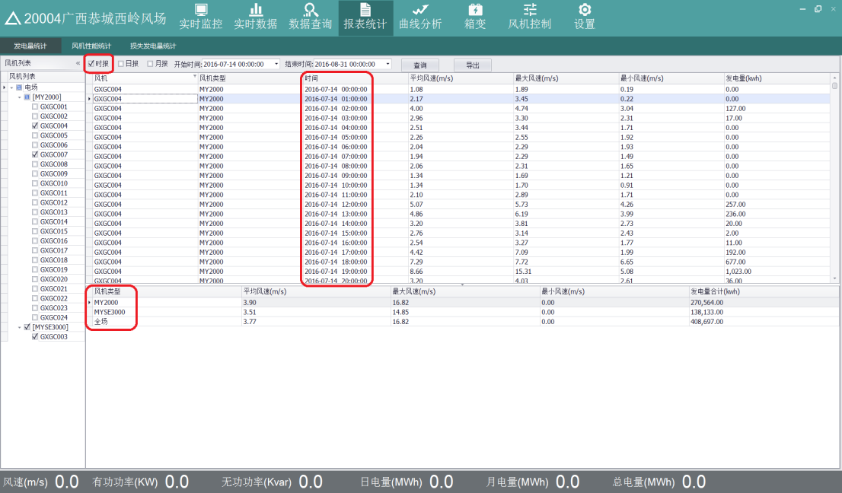

图 5.14 时报查询结果图

Figure 5.14 Hour Query Result Diagram

● 选择“日报”，查询的时间间隔为 1 天，如图 5.15 所示。

Select "Daily" and the query interval is 1 day, as shown in Figure 5.15. 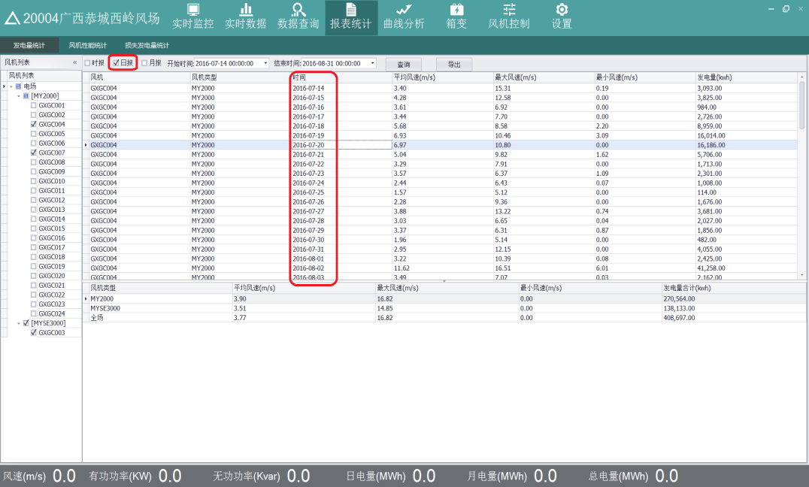

图 5.15 日报查询结果图

Figure 5.15 Daily Query Result Diagram

● 选择“月报”，查询的时间间隔为 1 月，如图 5.16 所示。

Select "Monthly Report" and the query interval is one month, as shown in Figure 5.16.

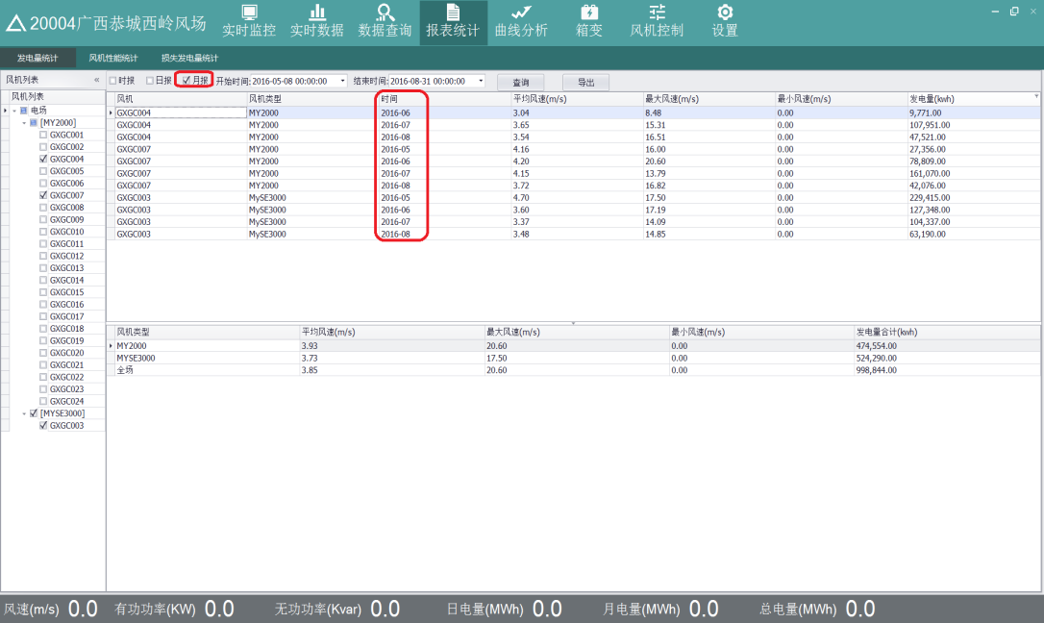

图 5.16 月报查询结果图

Figure 5.16 Query Result Diagram of Monthly Report

### 5.4.2风机性能统计 Performance Statistics of Wtgs

点击“报表统计”>“风机性能统计”，首先在左边风机列表中，选择要查询的风机，再在上边选择查询的开始时间和结束时间。查询条件选择完成后，点击“查询”，表格中显示查询的结果，上边表格为选择风机的信息，下边表格为全场的信息，主要包括风机、风速、有效风时、发电小时数、等效利用小时数、发电量、故障次数、故障小时数、可利用率。点击“导出明细”，可将上边表格的风机信息以 csv 格式导出到本地。点击“导出全场”，可将下边表格的全场信息以 csv 格式导出到本地。如图 5.17 所示。 Click "Report Statistics"> "Wtgs Performance Statistics". First, in the left wtgs list, select the wtgs to query, and then select the start and end time of the query. After the selection of query conditions is completed, click "Query", and the results of query are displayed in the table. The upper table is the information of selecting wtgs, and the lower table is the information of the whole field. It mainly includes wtgs, wind speed, effective wind time, generation hours, equivalent utilization hours, generation capacity, failure times, failure hours and availability. Rate. Click "Export Details" to export the wtgs information of the table above to the local area in CSV format. Click "Export the whole field" to export the full field information of the table below to the local area in CSV format. As shown in Figure 5.17.

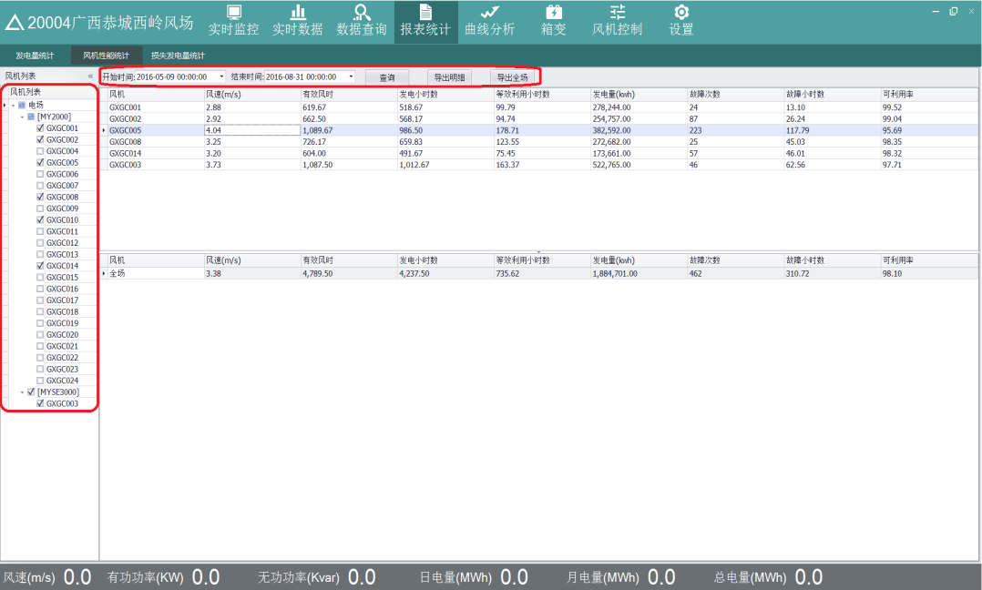

图 5.17 风机性能统计图

Figure 5.17 Statistical Chart of Wtgs Performance

### 5.4.3损失发电量统计 Loss statistics

点击“报表统计”->“损失发电量统计”，首先在左边风机列表中，选择要查询的风机，再在上边选择查询的开始时间和结束时间。查询条件选择完成后，点击“查询”，表格中显示查询的结果，主要包括风机、理论发电量、实际发电量、故障损失发电量等。点击“导出”，可将查询的信息以 csv 格式导出到本地。如图 5.17 所示。

Click "Report Statistics" - > "Loss Generation Statistics". First, in the left wtgs list, select the wtgs to query, and then select the start and end time of the query. After the selection of query conditions is completed, click on "Query", and the results of query are displayed in the table, including wtgs, theoretical power generation, actual power generation, fault loss power generation and so on. Click "Export" to export the query information to the local area in CSV format. As shown in Figure 5.17. 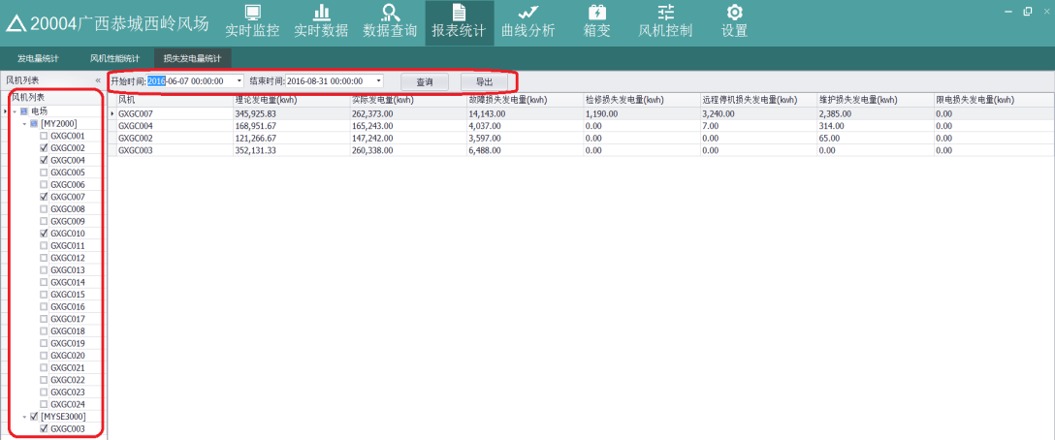

图 5.17 损失发电量统计图

Figure 5.17 Statistical Chart of Lost Generation

### 5.5曲线分析 Curve Analysis

点击主界面上面工具栏的“曲线分析”按钮，可查看风机的功率曲线、自由趋势（单台多点）、自由趋势（多台单点）、关系曲线、风频图。

Click the "Curve Analysis" button on the toolbar above the main interface to view the power curve, free trend (single point and multiple points), free trend (multiple points), relationship curve and wind frequency chart of the wtgs.

### 5.5.1功率曲线 Power curve

点击“曲线分析”->“功率曲线”，首先在左边风机列表中，选择要查询的风机，再在上边选择查询的开始时间和结束时间、曲线类别。

Click on "Curve Analysis" - > "Power Curve". First, in the left wtgs list, select the wtgs to query, and then select the start and end time of the query, curve category.

当曲线类别为趋势图时，最多可选择三台风机且类型相同；当曲线类别为散点图时，只能选择一台风机。查询条件选择完成后，点击“查询”，功率曲线显示如图 5.18（趋势图）、图 5.19（散点图）所示，横坐标为风速，纵坐标为功率。

When the curve type is trend chart, at most three wtgss can be selected with the same type; when the curve type is scatter plot, only one wtgs can be selected. When the query condition is selected, click "Query" and the power curve is shown as shown in Fig. 5.18 (Trend Chart) and Fig. 5.19 (Scatter Chart). The abscissa is wind speed and the longitudinal coordinate is power.

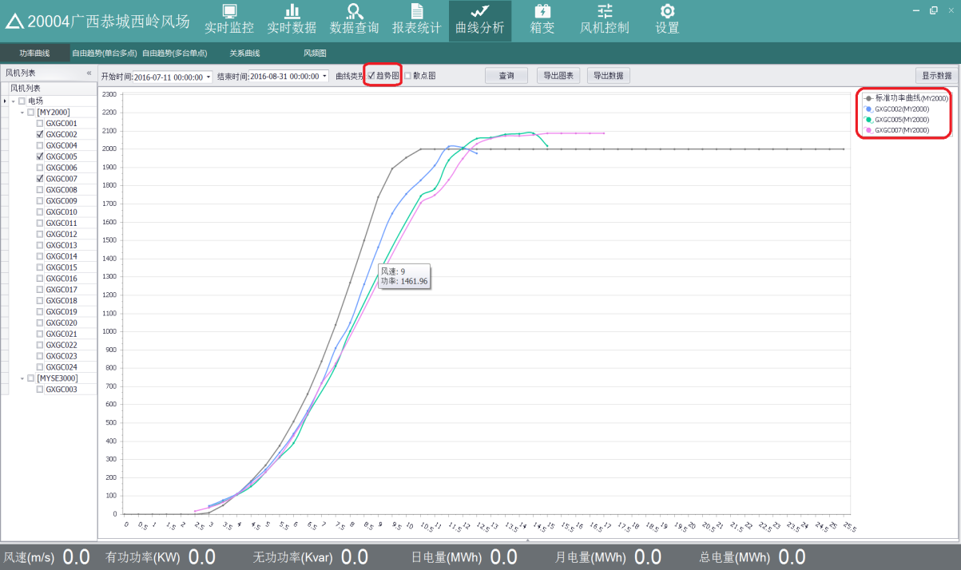

图 5.18 趋势图

Figure 5.18 Trend Chart

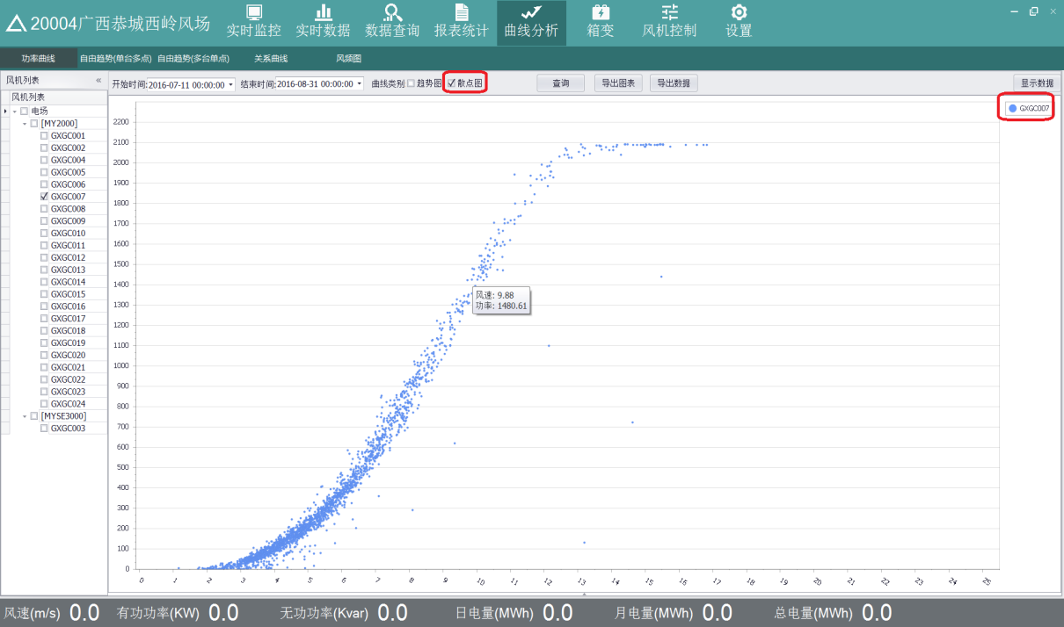

图 5.19 散点图

Figure 5.19 Scatter plot

当鼠标移动到曲线上的点时，会显示当前点的坐标，即该点的风速和功率值。曲线用不同的颜色显示，曲线的颜色和右上角的曲线名保持一致。

点击“导出图表”，可将曲线导出保存到本地。

点击“导出数据”，可将查询的结果数据以 csv 格式保存到本地。

点击“显示数据”，可将查询的结果数据显示到表格中，如图 5.20 所示。

When the mouse moves to the point on the curve, it will display the coordinates of the current point, that is, the wind speed and power value of the point. The curve is shown in different colors, and the color of the curve is consistent with the name of the curve in the upper right corner.

Click "Export Chart" to save the curve exportation to the local area.

Click "Export Data" to save the query result data in CSV format.

Click "Display Data" to display the results of the query into the table, as shown in Figure 5.20.

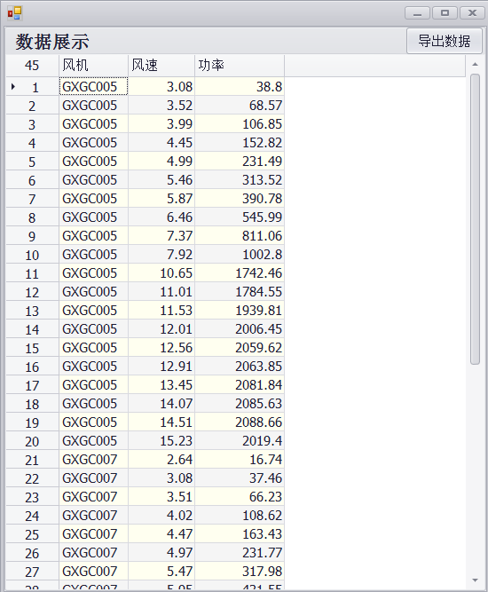

图 5.20 风速功率数据展示图

Figure 5.20 Wind Speed and Power Data Display Chart

### 5.5.2自由趋势（单台多点） Freedom Trend (Single Station and Multiple Points)

点击“曲线分析”->“自由趋势（单台多点）”，单台多点是指选择一台风机，多个 IO点进行查询，IO 量不能超过 3 个。首先在左边风机列表中，选择一台风机，再在中间的 IO 列表中，选择需要查询的 IO,最后选择查询的开始时间和结束时间，选择时间的区间不能大于 7 天。查询条件选择完成后，点击“查询”，曲线显示如图 5.21 所示。 Click on "Curve Analysis" - > "Free Trend" (single multi-point). Single multi-point refers to the selection of a wtgs, multiple IO points for query, IO can not exceed 3. First, in the left wtgs list, select a wtgs, then in the middle of the IO list, select the IO to query, and finally select the start and end time of the query, the selection time can not be greater than 7 days. When the query condition is selected, click "Query" and the curve is shown in Figure 5.21.

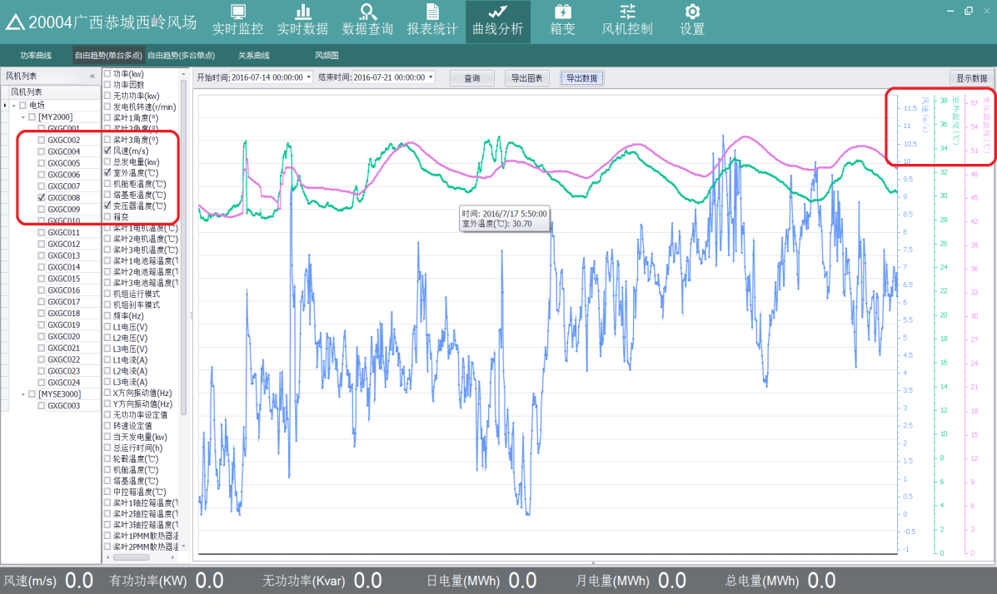

图 5.21 自由趋势图

Figure 5.21 Free Trend Chart

当鼠标移动到曲线的点上时，会显示当前点的值，横坐标为时间，纵坐标为相应 IO 的值，此曲线为多纵坐标轴，每个 IO 对应一个坐标轴，曲线用不同的颜色表示，曲线的颜色和右上角的曲线名保持一致。

点击“导出图表”，可将曲线导出保存到本地。

点击“导出数据”，可将查询的结果数据以 csv 格式保存到本地。

点击“显示数据”，可将查询的结果数据显示到表格中，如图 5.22 所示。 When the mouse moves to the point of the curve, it will show the value of the current point. The abscissa is time and the ordinate is IO. The curve is multi-ordinate axis. Each IO corresponds to a coordinate axis. The curve is represented by different colors. The color of the curve is consistent with the name of the curve in the upper right corner.

Click "Export Chart" to save the curve exportation to the local area.

Click "Export Data" to save the query result data in CSV format.

Click "Display Data" to display the result data of the query in the table, as shown in Figure 5.22. 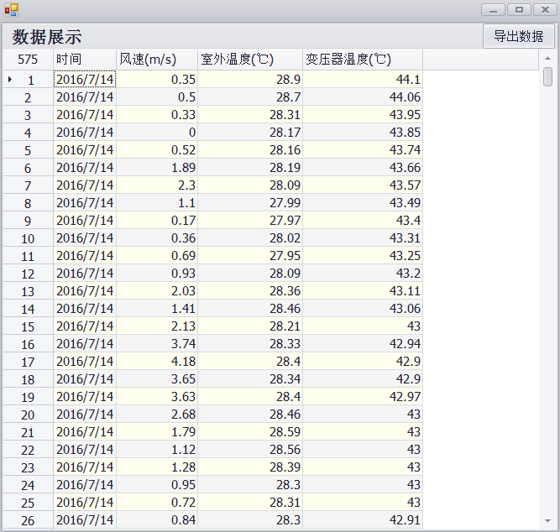

图 5.22 风速温度数据展示图

Figure 5.22 Wind speed and temperature data display

### 5.5.3自由趋势（多台单点）Freedom Trends (Multiple Single Points)

点击“曲线分析”->“自由趋势（多台单点）”，多台单点是指选择多台风机，单个 IO点进行查询，所选风机的类型必须相同，因为不同类型的风机，对应的 IO 量不同。首先在左边风机列表中，选择多台风机，再在中间的 IO 列表中，选择需要查询的 IO,最后选择查询的开始时间和结束时间，选择时间的区间不能大于 7 天。查询条件选择完成后，

点击“查询”，曲线显示如图 5.23 所示。 Click on "Curve Analysis" - > "Free Trend (Multiple Single Points)", multiple single points refer to the selection of multiple wtgss, single IO point for query, the type of selected wtgss must be the same, because different types of wtgss, the corresponding IO volume is different. First, in the left wtgs list, select multiple wtgss, then in the middle of the IO list, select the IO that needs to be queried, and finally select the start and end time of the query, the selection time can not be greater than 7 days. When the query condition selection is completed,

Click "Query" and the curve is shown in Figure 5.23.

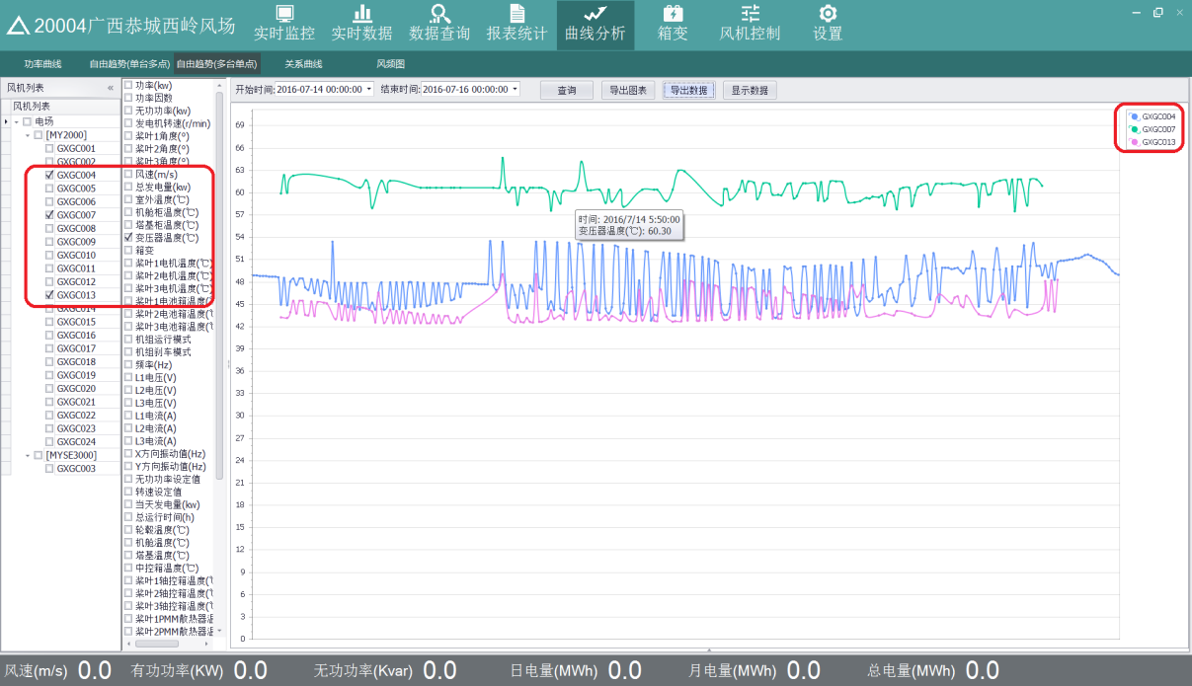

图 5.23 曲线显示图

Figure 5.23 Curve Display

当鼠标移动到曲线的点上时，会显示当前点的值，横坐标为时间，纵坐标为相应 IO 的值。曲线用不同的颜色表示，曲线的颜色和右上角的曲线名保持一致。

点击“导出图表”，可将曲线导出保存到本地。

点击“导出数据”，可将查询的结果数据以 csv 格式保存到本地。

点击“显示数据”，可将查询的结果数据显示到表格中，如图 5.24 所示。 When the mouse moves to the point of the curve, the value of the current point will be displayed. The abscissa is the time and the ordinate is the value of the corresponding IO. The curve is represented by different colors, and the color of the curve is consistent with the name of the curve in the upper right corner.

Click "Export Chart" to save the curve exportation to the local area.

Click "Export Data" to save the query result data in CSV format.

Click "Display Data" to display the result data of the query in the table, as shown in Figure 5.24.

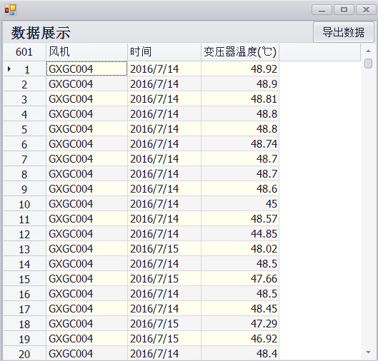

图 5.24 温度数据展示图

Figure 5.24 Temperature Data Display

### 5.5.4关系曲线 Relation curve

点击“曲线分析”->“关系曲线”，首先在左边风机列表中，选择一台风机，再在中间的 IO 列表中，选择两个 IO 量，最后选择查询的开始时间和结束时间。查询条件选择完成后，点击“查询”，这两个 IO 量的曲线关系显示如图 5.25 所示。 Click "Curve Analysis" - > "Relational Curve", first select a wtgs in the left wtgs list, then select two IO quantities in the middle IO list, and finally select the start and end time of the query. When the query condition is selected, click "Query" and the curve relationship between the two IO quantities is shown in Figure 5.25.

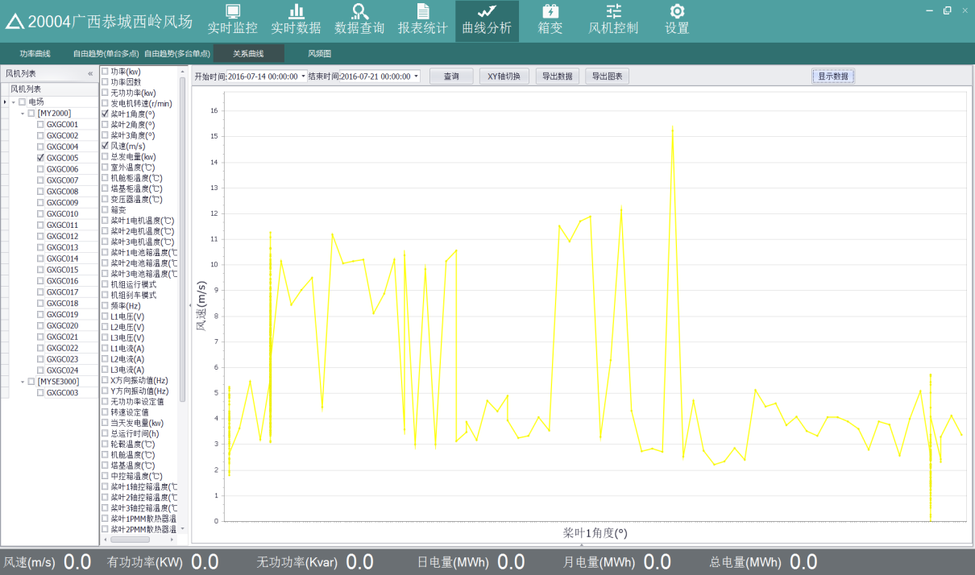

图 5.25 曲线关系图

Figure 5.25 Curve Diagram

在图中，选择的两个 IO 为浆叶 1 角度和风速，曲线的横坐标为浆叶 1 角度，纵坐标为风速，曲线表示它们之间的关系趋势图。点击“XY 轴切换”，即交换曲线的坐标，横坐标为风速，纵坐标为浆叶 1 角度，如图 5.26 所示。

In the figure, two IOs are selected as blade 1 angle and wind speed, the abscissa of the curve is blade 1 angle, and the longitudinal coordinate is wind speed. The curve shows the trend chart of their relationship. Click "XY axis switching", that is, the coordinates of the switching curve, the abscissa is wind speed, and the longitudinal coordinates are blade angle 1, as shown in Figure 5.26.

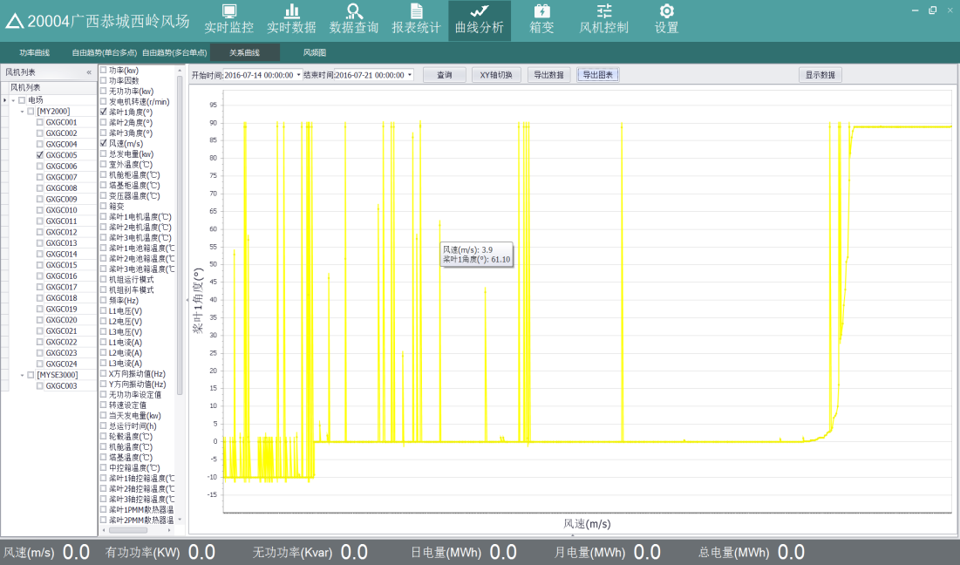

图 5.26 角度和风速图

Figure 5.26 Angle and Wind Velocity Diagram

点击“导出图表”，可将曲线导出保存到本地。

点击“导出数据”，可将查询的结果数据以 csv 格式保存到本地。

点击“显示数据”，可将查询的结果数据显示到表格中，如图 5.27 所示。 Click "Export Chart" to save the curve exportation to the local area.

Click "Export Data" to save the query result data in CSV format.

Click "Display Data" to display the results of the query in the table, as shown in Figure 5.27.

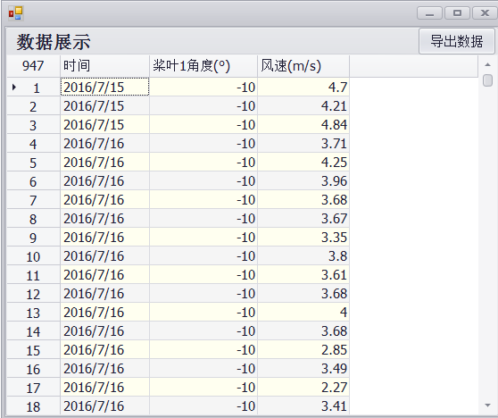

图 5.27 角度风速数据展示图

Figure 5.27 Angle Wind Speed Data Display

### 5.5.5风频图 Wind frequency diagram

点击“曲线分析”->“风频图”，首先在左边风机列表中，选择风机，最多选择 3 台，再选择查询的开始时间和结束时间。查询条件选择完成后，点击“查询”，曲线显示如图 5.28所示，横坐标为风速，纵坐标为风频。

Click on "Curve Analysis" - > "Wind Frequency Diagram". First, in the list of left wtgss, select wtgss, up to three, and then select the start and end time of the query. When the query condition is selected, click "Query" and the curve shows as shown in Figure 5.28. The abscissa coordinate is wind speed and the ordinate coordinate is wind frequency.

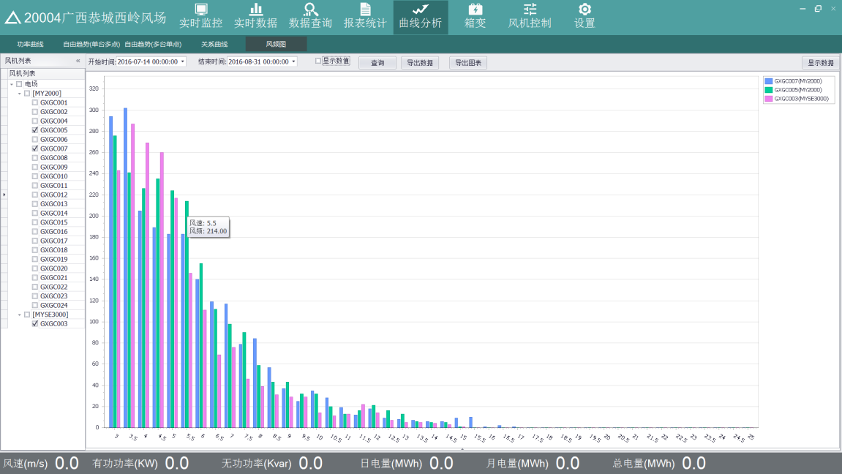

图 5.28 风频图Figure 5.28 Wind Frequency Diagram

点击“显示数值”，曲线上显示每个点的值，如图 5.29 所示。 Click on "Display Numbers" to display the values of each point on the curve, as shown in Figure 5.29.

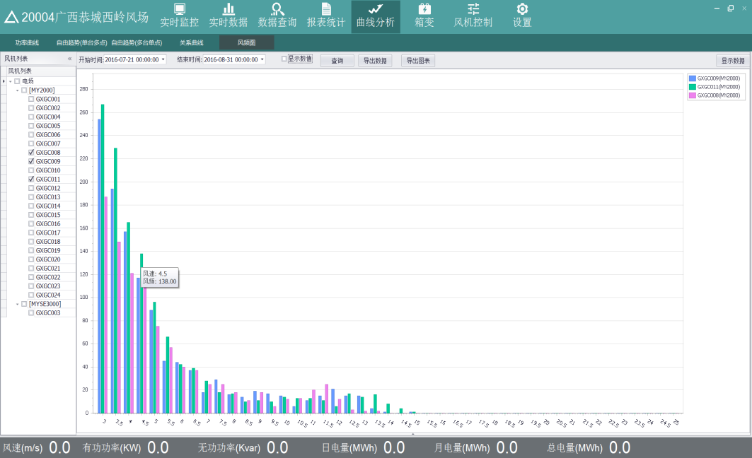

图 5.30 曲线值显示图

Figure 5.30 Curve Value Display

点击“导出图表”，可将曲线导出保存到本地。

点击“导出数据”，可将查询的结果数据以 csv 格式保存到本地。

点击“显示数据”，可将查询的结果数据显示到表格中，如图 5.31 所示。

Click "Export Chart" to save the curve exportation to the local area.

Click "Export Data" to save the query result data in CSV format.

Click "Display Data" to display the result data of the query in the table, as shown in Figure 5.31.

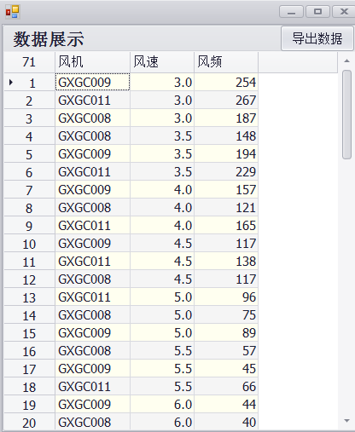

图 5.31 风速风频数据展示图

Figure 5.31 Wind Speed and Frequency Data Display Chart

### 5.6箱变 Box Transformer

点击主界面上面工具栏的“箱变”按钮，可查看风电机组箱变的 IO 和 SC 的值，点击左边某个箱变，右边显示其对应的 IO 和 SC，如图 5.32 所示。 Click on the "box change" button in the toolbar above the main interface to view the values of IO and SC of Wtgs box change, click on a box change on the left, and display its corresponding IO and SC on the right, as shown in Figure 5.32.

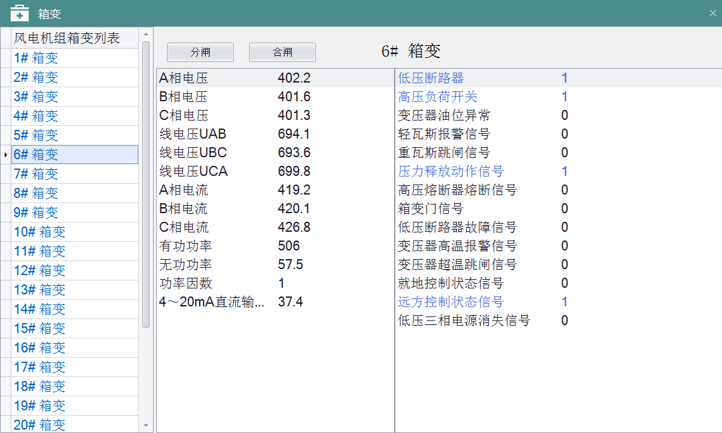

图 5.32 箱变显示图

Figure 5.32 Box Variable Display Diagram

选中箱变，点击“分闸”或“合闸”，可对其进行分闸或合闸操作。

Select the box to change, click on "switch-off" or "close" to open or close it.

### 5.7风机控制 Wind Turbine Generator System(Wtgs) control

点击主界面上面工具栏的“风机控制”按钮，可对风机进行控制相关的操作，全部控制动作均会保存相应的记录。

可选择单台风机，可选多台或全部，点击“全选”，可将风机全部选中。点击“反选”，取消选中。如图 5.33 所示。 Click on the "Wtgs Control" button in the toolbar above the main interface to control the related operation of the wtgs. All control actions will be saved corresponding records.

You can choose a single wtgs, multiple or all of them. Click "Select all", and you can select all of them. Click "Back" and uncheck. As shown in Figure 5.33.

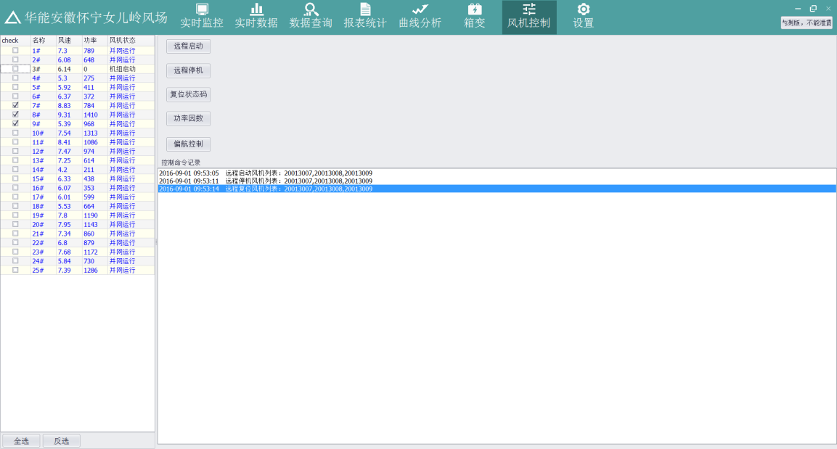

图 5.33 风机控制图

Fig. 5.33 Wtgs Control Chart

### 5.7.1风机启停机 Wtgs start-up and shutdown

选中风机后，点击“远程启动”或“远程停机”，可对风机进行启动、停机操作。

After selecting the wtgs, click "remote start" or "remote shutdown" to start and stop the wtgs.

### 5.7.2风机复位 Wtgs reset

选中风机后，点击“复位状态码”，可对风机进行相应的复位操作。

After selecting the wtgs, click on the "reset status code" to reset the wtgs accordingly.

### 5.7.3功率因数 power factor

点击“功率因数”，可以手动设置风机的功率因数，选中一台风机，在右边功率因数后的编辑框输入值，功率因数值的范围为 0.95~1，点击“修改”，即保存到当前功率因数值一栏，变为启用状态。点击“禁用”，可将风机的功率因数禁用。如图 5.34 所示。

Click on "Power Factor" to set the power factor of the wtgs manually. Select a wtgs and input the value in the edit box after the power factor on the right. The range of the power factor value is 0.95~1. Click "Modify", that is to say, save it to the current power factor value column and turn it on. Click "Disable" to disable the power factor of the wtgs. As shown in Figure 5.34.

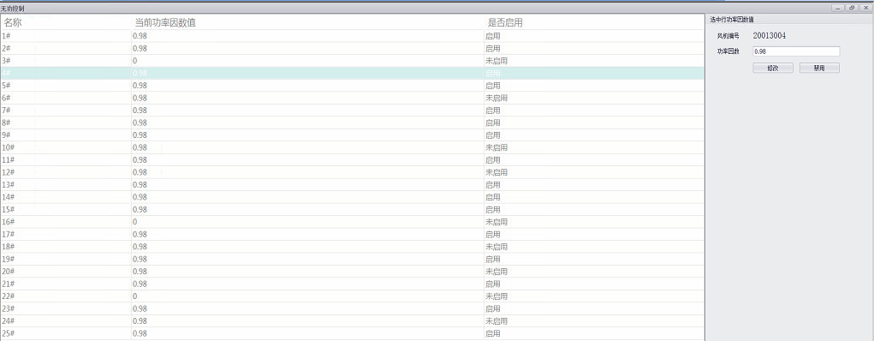

图 5.34 功率因数图

Figure 5.34 Power Factor Diagram

### 5.7.4偏航控制 Yaw control

点击“偏航控制”，可以对风机进行自动偏航控制或手动偏航控制，如图 5.35 所示。

Click "Yaw Control" to control the wtgs automatically or manually, as shown in Fig. 5.35. 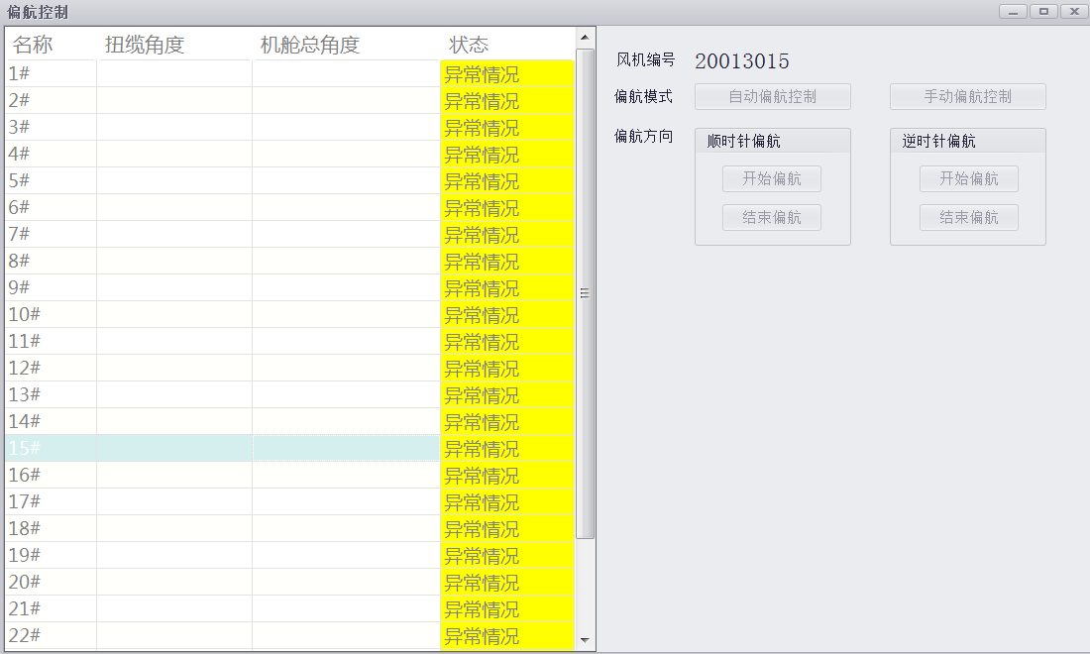

图 5.36 偏航控制图

Figure 5.36 Yaw Control Chart

当风机状态为异常情况时不能操作，当为自动或手动时，可以在右侧选择自动偏航控制或手动偏航控制，当选择自动偏航控制时，不用操作偏航方向。当选择手动偏航控制时，需操作偏航方向，顺时针偏航或逆时针偏航。

When the wtgs state is abnormal, it can not be operated. When it is automatic or manual, automatic yaw control or manual yaw control can be selected on the right side. When automatic yaw control is selected, yaw direction is not operated. When choosing manual yaw control, it is necessary to operate the yaw direction, clockwise yaw or counter-clockwise yaw.

### 5.8设置 Set up

点击主界面上面工具栏的“设置”按钮，可查看当前系统的客户端版本和服务端版本。

Click on the "Settings" button in the toolbar above the main interface to view the client and server versions of the current system.